North Country Spouse’s Club

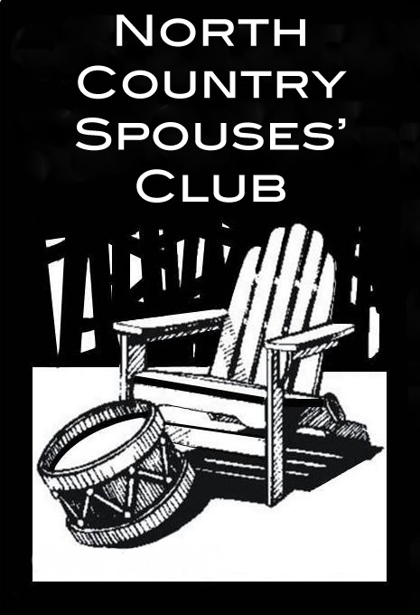

Appointed Board Application

We need YOU!!! Would you like to be part of an altruistic, energetic, and fun-loving group? A group that makes the decisions that keep the NCSC viable and beneficial to the community, but has great camaraderie and fun at the same time? If you answered yes to either of these questions, then the NCSC Appointed Board needs you!
We are currently accepting applications for positions on the NCSC Board for 2020-2021. These positions do not require previous board experience. If you have been looking for a way to be involved, this is your opportunity. Job descriptions for each position are available on our website at http://www.northcountryspousesclub.com/ncsc- board.html.
To submit your completed application or for additional information, please contact Christian King, NCSC Parliamentarian via email: parliamentarianncsc@gmail.com.

Position of Interest: ____________________________________
Name: ______________________________________________
Address: ____________________________________________
Email Address: _______________________________________
Phone Number: _______________________________________
Spouse’s Name and Organization: ________________________
Previous Board Experiences/Other Boards Serving on in 2020-2021: __________________________________________________________________________________________________________________________________________________________________
Why are you interested in serving on the Appointed Board?
______________________________________________________________________________________________________________________________________________________________________________________________________________________________________________________________________________
Signature:
Application Deadline for Appointed Positions: August 15, 2020

